**Practical No 2**

**Aim:-** Exploratory Data Analysis for handling missing and categorical values.

**Steps:-**

1. Open Your Folder in RStudio and set that folder as working directory.

> setwd("C:/Users/user/Desktop/Eda-master")

1. Install package..devtools

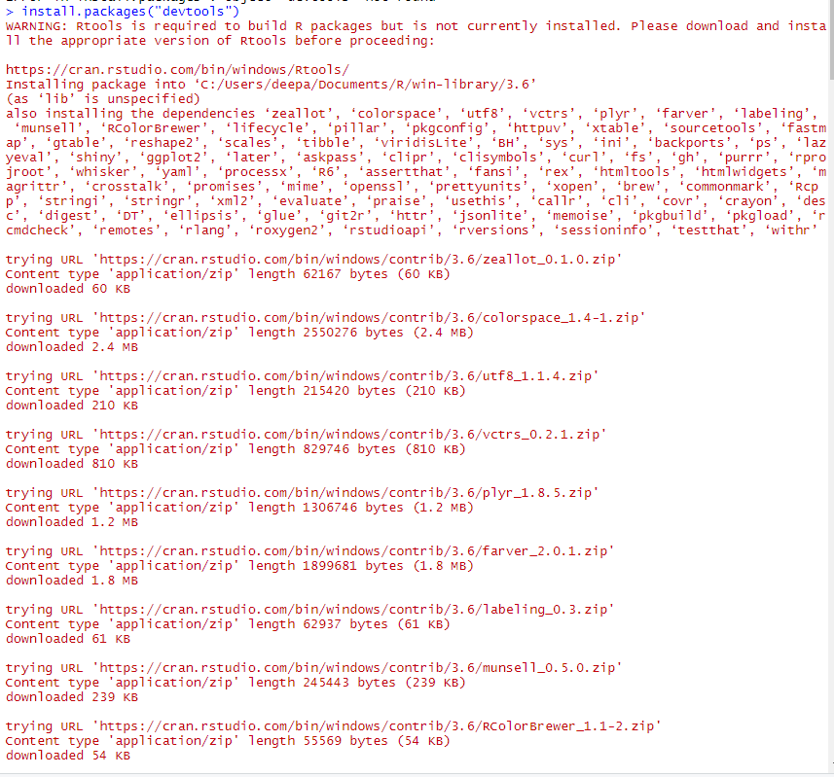

1. Import dataset file(.csv) to R

> dataset = read.csv('Data.csv')

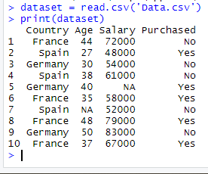

1. Taking care of missing data

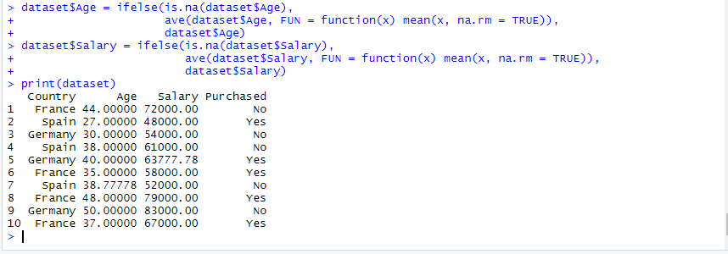

1. Encoding categorical data

